Week 1: Understanding the World

Busy Things online

www.busythings.co.uk
Here is the log in for Busy Things;
Username Oasis16
Password Gruff7657

There are lots of games where they learn through play on here. If you go on the Nursery function then ‘Top 40 games’ your child will recognise this web page and will be able to choose a game to play. You could choose a specific game you would like them to play, for example Maths or Literacy if by choosing these for them.
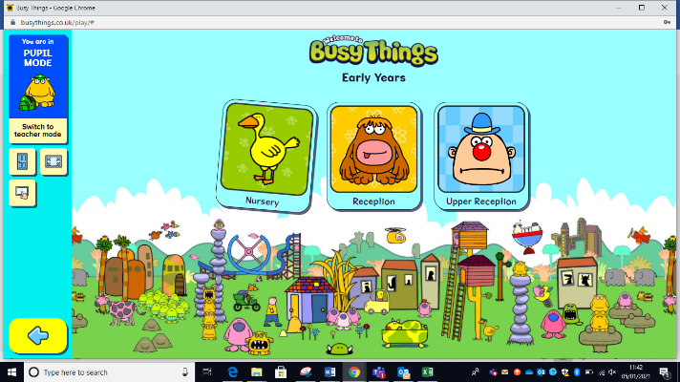
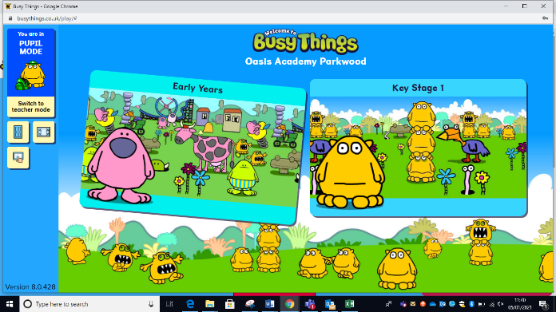
Please set your own limit for them to be on this website, in school they are limited to a 10 minute sand timer per turn during free play.
