Oak Online Learning Maths 8.1.21
Exploring Capacity part 2

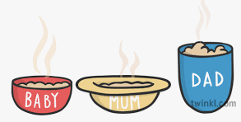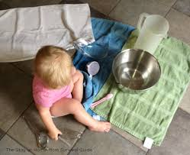
Extending the play your child engaged with Wednesday, which container can hold the most water? Which one can hold the least water? You could introduce the words ‘biggest capacity’ and ‘smallest capacity’.
Try adding containers with holes, ask your child why they can’t fill this container. Allow them to explore this.

Recap: Can your child show you their container full, empty, half full, nearly full and nearly empty? You could get them to point to these images to help.

