Viking Portal story.
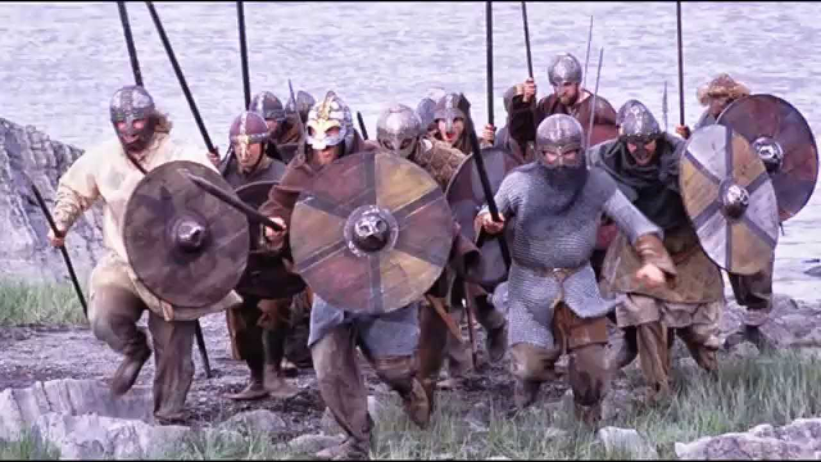

What is your portal? How will you go back in time?

Where do you end up? (Setting):

Who do you meet? (Character):

What is happening? (Tense action):

Ending – How do you return safely back home?

