Name __________________
Newspaper report plan
WALT: plan a news report
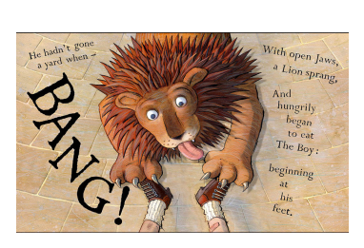
Headline (snappy, short & eye-catching)

Orientation?

Who?
What?
Why?
Where?
When?

What are the details you need to include?

How will you refer to the lion?

Quotes (Who will speak? What will they say? How will you introduce the quote?)

How will you finish your news report? (Re-orientation, summary of events)

