WALT consider how authors have developed characters and settings
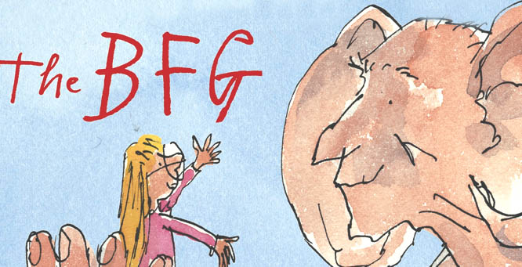

Can you find examples of each of these features Roald Dahl uses to describe the BFG?
Short Sentences
Power of 3…
Character’s feelings
2 Adjective sentence
Weird/strange behaviour
Rhetorical Questions
USE OF CAPITALS
Use of odd equipment

