Kingdom
Of the
Saxons
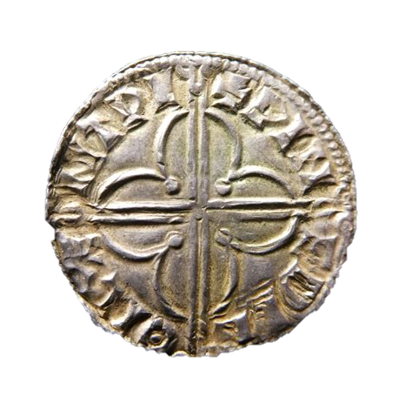

PASSPORT

Name:
Age:
Place of birth:
Occupation:

Where are you going to settle?
How did you travel to Britain?
Why have you travelled here?

