The bear who came to babysit – comprehension questions.
Pages 1 - 4
Read the questions carefully and answer in full sentences.

- Where are Mum and Mike going at the beginning of the story? (2b)
- What type of animal shows up to babysit the children? (2b)
- What does the bear give the children for breakfast? (2b)
- What happens when the bear squeezes the bubble bath? (2b)
- What do you think the word ‘laundry’ means? (2g)
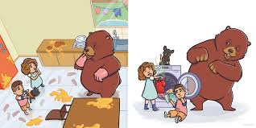
- What does the word ‘speechless’ suggest how the children are feeling? (2f)

