Literacy.
Thursday 7th January, 2021.

Today we are going to continue to look at nouns but, we are going to be focussing on proper nouns.
Do you know what a proper noun is?

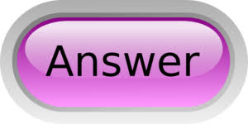
A proper noun is the name of a specific item, person or place and will always begin with a capital letter no matter where it occurs in a sentence.

Proper nouns give a specific name to a common noun.
Can you remember, from the previous lesson, what a common noun is?
Common nouns name a person, place, animal or thing.

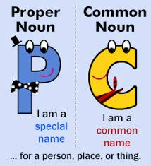
Please click on the link below to learn more about proper nouns.
https://www.youtube.com/watch?v=8WY4hhpJVDk
Today’s task.
Write the sentences and then underline the proper nouns in blue. The first one has already been done for you.
- The mechanic who repaired our car at the garage is called Dave.
- London is an exciting city to visit. Buckingham Palace is my favourite building.
- "Please take a seat. Doctor Mills will be with you shortly."
- I hope that we have lots of snow in November or December.
- Every Saturday I take my dog, Patch, to Bramble Park.
- The software on my computer includes Microsoft Word and Microsoft Excel.
- I built a model of the Statue Of Liberty out of Lego bricks.

Challenge
Read your sentences again. Can you recognise the common nouns in the sentences? Underline all of the common nouns you can see in the sentences in red.

Please remember to photograph your child’s work and send it to your class teacher using Class DOJO.

