History – Wb 11.1.21
WALT: Create a timeline of Albert Einstein’s life

Our first ‘Great Inventor’ is Albert Einstein!
Questions to think about:
Have you heard of Albert Einstein before?
Do you know anything about Albert Einstein already?

Albert Einstein was a great scientist and inventor and achieved many accomplishments in his lifetime.
One of these accomplishments is that he discovered that sound travels through the atmosphere in sound waves. He discovered that sound also travels through the atmosphere much slower than light.
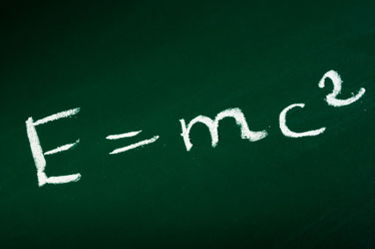

Task: Correctly order and write out the events below about Albert Einstein’s life as a timeline. You may set this out portrait, landscape, however you would like.
1879: Albert was born in Germany. | 1895: Albert moved to Switzerland at 16 years old. | 1919: Einstein’s name spread around the world due to his success.
1896: Albert graduates at the top of his class. | 1894: Albert finishes school and moves to Milan (Italy). | 1922: He was awarded the first Nobel Prize.
1884: At aged 5, Albert saw his first compass and was fascinated. | 1889: When Albert was 10, he was introduced to maths and science. | 1909: He got a job teaching physics at the University of Zurich.
1945: WWII ended and Einstein continued his research. | 1933: He visited America for the first time. | 1905: Einstein wrote his first of many books.
1913: Began working on a new explanation for gravity. | 1955: Albert Einstein died in April of heart failure.

Take a picture of your finished timeline and upload to Class Dojo for your teacher to see!

