Year 3 Maths – Thursday 7th January

Today, we will be looking at the 4x table, particularly through skip counting. Remember skip counting is counting forwards or backwards by any number apart from one. To skip count we keep adding the same number each time to the previous number.
First, have a go at the introductory quiz, watch the video and complete the activities.
Then, have a go at the worksheet and the final quiz to test your learning from this lesson.
Follow the link to today’s lesson:
https://classroom.thenational.academy/lessons/recalling-the-4-times-table-cmt64e
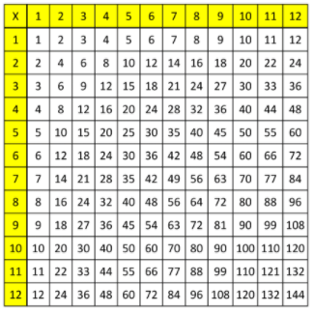
Please complete all the activities and worksheet questions on paper and upload a photograph of them onto class dojo. Please also upload a photograph of the completed quiz.

