Year 3 Maths – Friday 8th January

Mathletics & TT Rockstars
This week, we have been looking at our 3 and 4x tables.
See what you have learnt on Mathletics and TT Rockstars and have a go at some of the activities online.
If you are struggling to log on to Mathletics and TT Rockstars, please contact your class teacher.

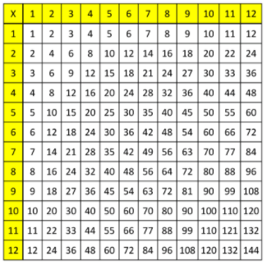
Take a picture and upload through Class Dojo for your teacher to see.

