Maths
Week 1: Monday 27th April 2020
Today we are going to try doubling different numbers.
Remember doubling a number is adding the same number again.
Gather some objects to help you with your doubling.
Choose a number and count out the objects to represent the number you have chosen.

Then try doubling it.
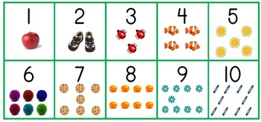
Can you write the number you started with and the number you have once it has been doubled.

Remember to take some picture and add them to Class Dojo.

