Literacy
Week 1: Monday 27th April 2020
This week we are going to start looking at our new book for the next few weeks The Very Hungry Caterpillar.
Watch the story here
https://www.youtube.com/watch?v=75NQK-Sm1YY

When you have finished the story discuss and answer these questions with an adult.
- Who were the main characters in the story?
- What happens at the beginning of the story?
- What happens in the middle of the story?
- What happens at the end of the story?
- What words would you use to describe the caterpillar? Why?
- How does the caterpillar change throughout the story?
- What was your favourite part of the story? Why?
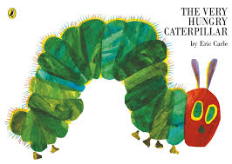

Remember to take some picture and add them to Class Dojo.

