Literacy
Week 1: Wednesday 29th April 2020
This week we are going to look at the lifecycle of a caterpillar.
Look at the lifecycle from yesterday’s work to begin.
Using the pictures below or drawing your own pictures can you put them into the correct order to form the lifecycle of a caterpillar.
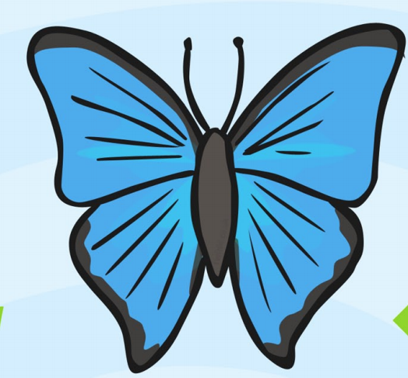
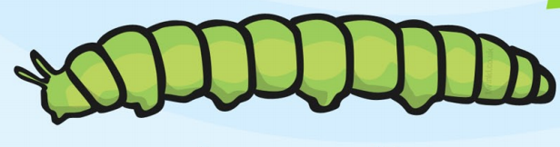

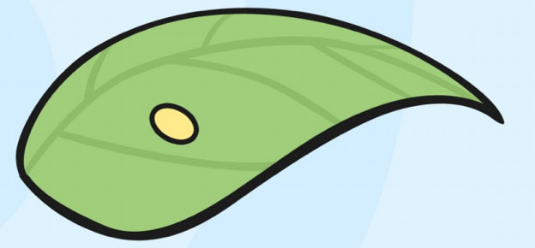

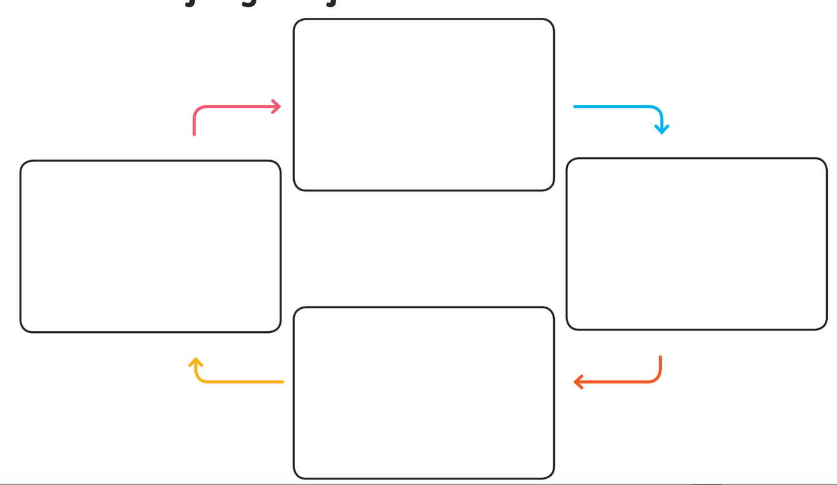
You could make your lifecycle like the pictures below

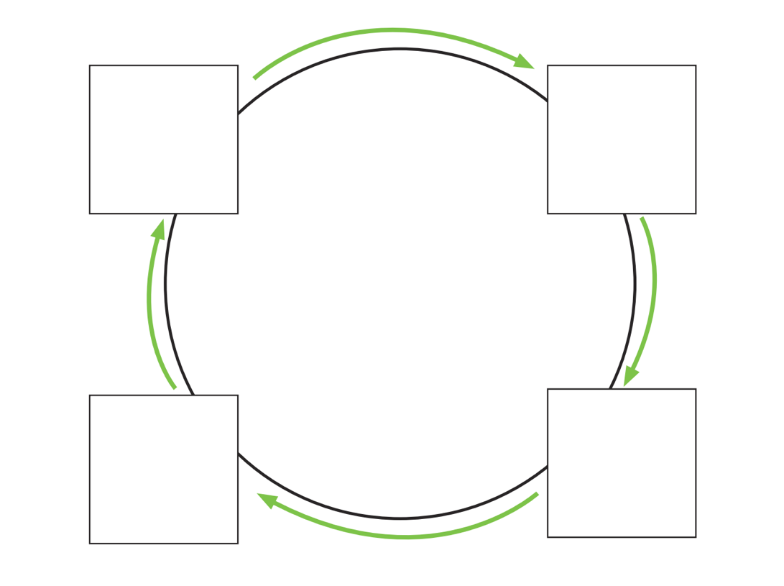

Once you have sequenced your lifecycle you need to:
- Label each picture correctly
- Have a go at writing a sentence for the first two parts of the lifecycle to explain what is happening.
- Try using words like first and next to start your sentences.
Here are some words that may help:
butterfly

egg
hatch

grow
leaf

larva
caterpillar

