Week 2: Understanding the World

Flowers

Can you find a daisy outside?
Look at your daisy carefully and see if you can find the stem and petals.
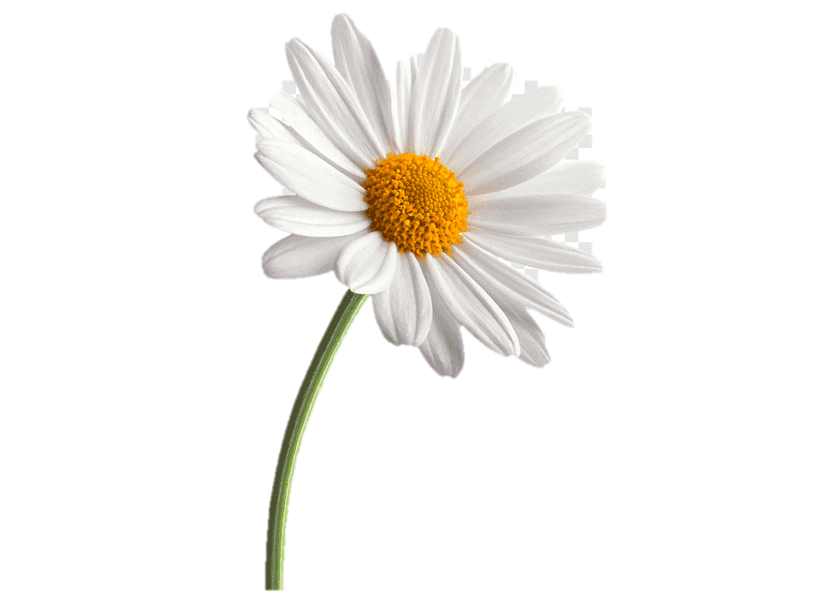
Stem
Petals

Please send picture of you with your daisy to Miss Lynaugh on Class Dojo!

