Maths
Week 2: Friday 12th June 2020
Length.
Ask a family member to lay on the floor and find some pencils.
Place the pencils in a line next to the person, making sure the pencils are the same length as them.
Count the pencils, this is how many pencils long they are! Can you write the number, or show it on your fingers?
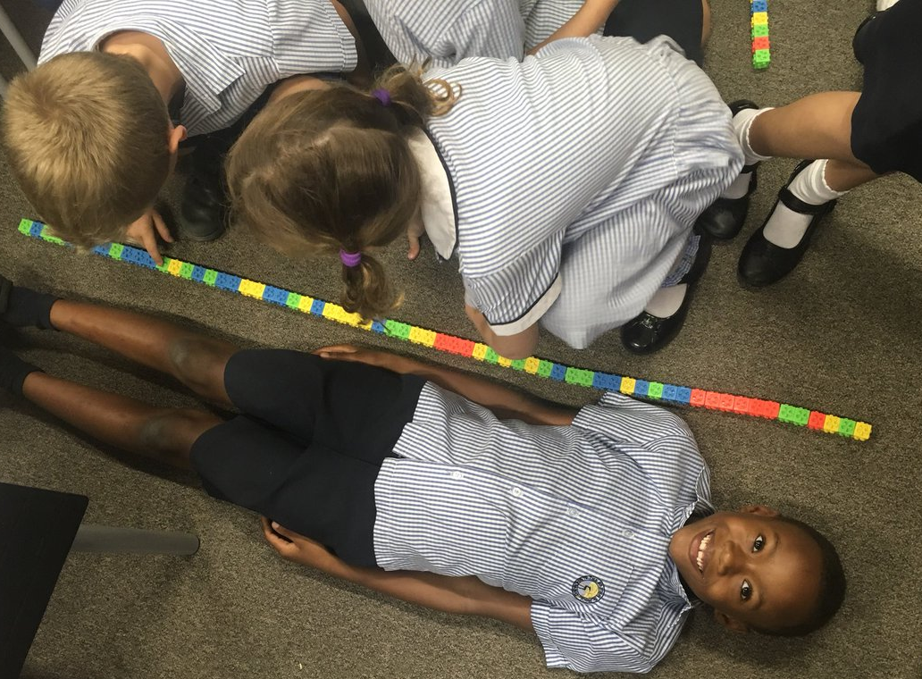

These children used cubes to measure how long their friend is.

Please send Miss Lynaugh a picture of your work on Class Dojo!

