Week 2: Communication and Language

Simon Says

Play a game or ‘Simon Says’ with your family. Who will be the winner?

How Do You Play Simon Says?
One person the leader. In this game, they are known as “Simon.”
Simon’s job is to tell the others an action, such as ‘Simon says pat your head’. If Simon begins a sentence with ‘Simon says…’ you should do the action. If he does not say this, then you are not allowed to do the action.
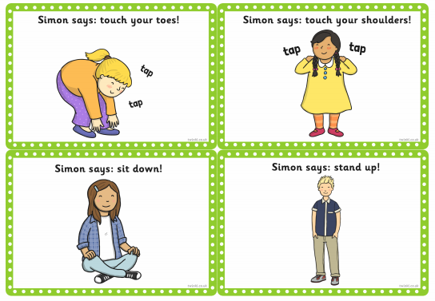
If Simon calls out “Touch your toes!” (without starting by saying “Simon says..”) then players are NOT supposed to touch their toes. If anyone touches their toes, they are out!

Please send Miss Lynaugh a picture of the items you found on Class Dojo!

