Literacy
Week 6: Tuesday 7th July 2020
This week we will continue to focus on Superworm.
You can listen to the story again using the link below:
https://www.youtube.com/watch?v=7Jnk3XApKBg
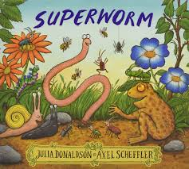

What sounds does Superworm begin with?

Can you find 2 objects in your house that begin with S?

Some ideas are: sock, slipper, scissors, slide or suitcase.

Please send a photograph of what you find to Miss Lynaugh on Class Dojo!

