Week 6: Expressive Arts and Design

Make A Magic Wand:

In Superworm, Wizard Lizard has a magical flower to cast spells. Can you make your own magic wand?
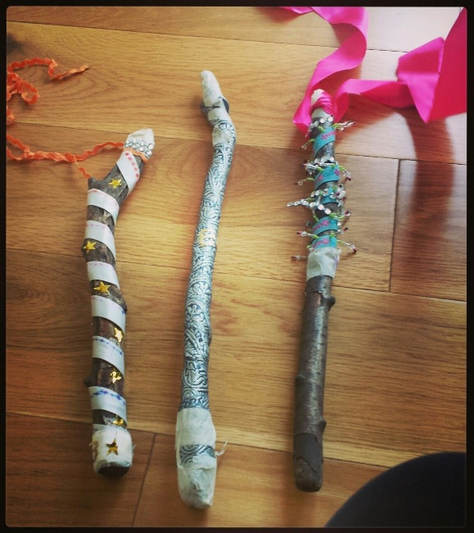
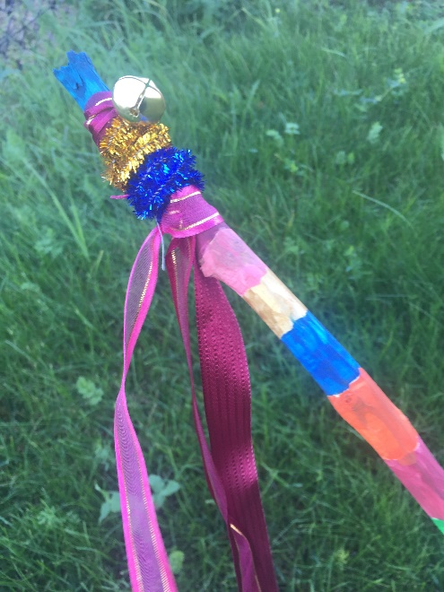

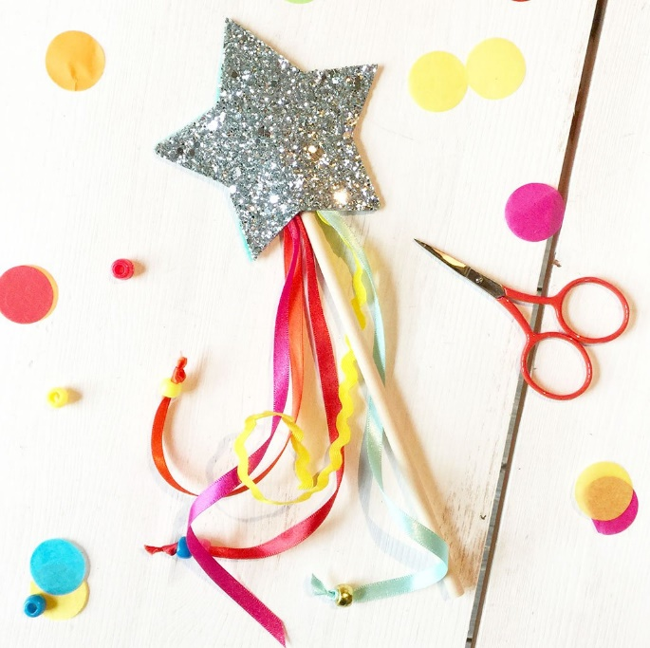
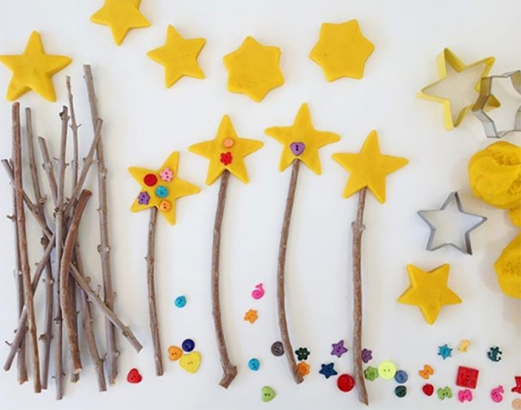

Please send a photograph of your magic wand to Miss Lynaugh on Class Dojo!

