Literacy
Week 6: Tuesday 7th July 2020
This week we will continue to focus on Superworm.
You can listen to the story again using the link below:
https://www.youtube.com/watch?v=7Jnk3XApKBg
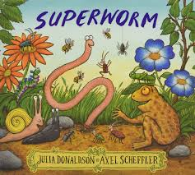

What sounds does Crow begin with?

Can you find 2 objects in your house that begin with C or K?
(c and k share the same sound, the objects you find can be either c or k as the focus is on hearing the sound and not spellings.)

Some ideas are: cat, cushion, carrot, candle, kettle or key.

Please send a photograph of what you find to Miss Lynaugh on Class Dojo!

