Maths
Week 6: Monday 6th July 2020
Repeating patterns

Can you continue these patterns?
You could say ‘one red, one blue, one red, one blue’ to help you!
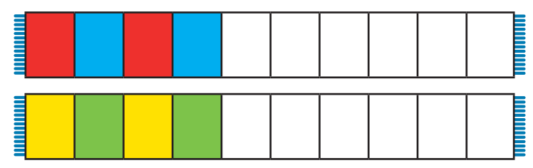

Please send Miss Lynaugh a picture of your work on Class Dojo!

