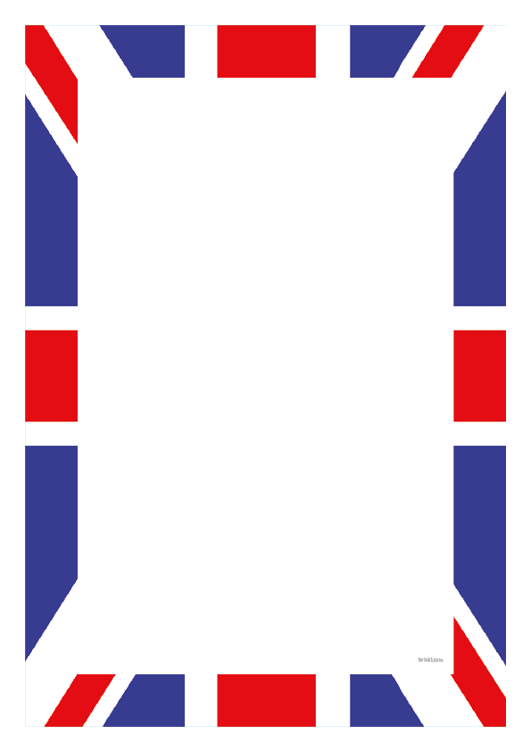

VE Day Activity One

Expressive arts and design

On Friday we will be celebrating the 75th Anniversary of VE Day.

Can you find out what VE Day is and why we celebrating it?

You can make a poster to display in your window, to let everyone know you will be celebrating VE Day on Friday.

Here are some you can print and colour!

