Literacy
Week 2: Tuesday 5th May 2020
In the book we are learning about, The Very Hungry Caterpillar, the caterpillar changes in to a beautiful butterfly!
You can watch the story again here
https://www.youtube.com/watch?v=75NQK-Sm1YY
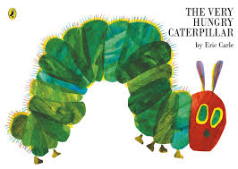

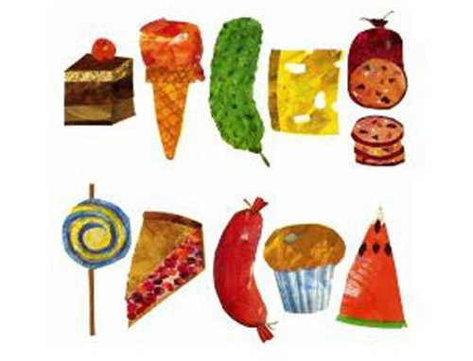
Can you draw some of the food the caterpillar eats and label it? Try and write the first sound; a for apple, or the word!

Please send a photograph to Miss Lynaugh on Class Dojo!

