Week 5: Understanding the World

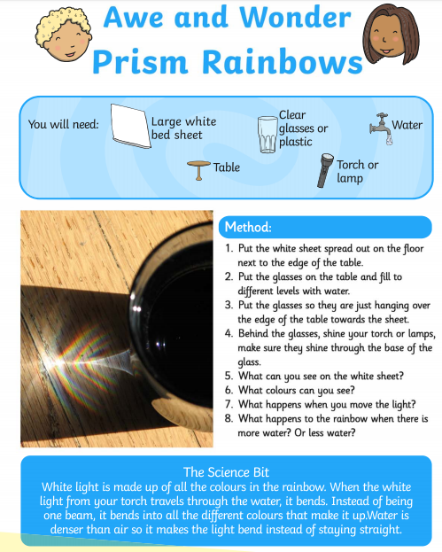
Trying completing the experiment below to create your own rainbows!

Please send pictures of your rainbows to Miss Lynaugh on Class Dojo!

