Week 1: Physical Development

Can you do Andy’s Creepy Crawly Workout?

https://www.bbc.co.uk/iplayer/episode/p06tmry2/andys-wild-workouts-series-1-9-the-undergrowth

Can you spread butter or jam on bread, or cut up your food?

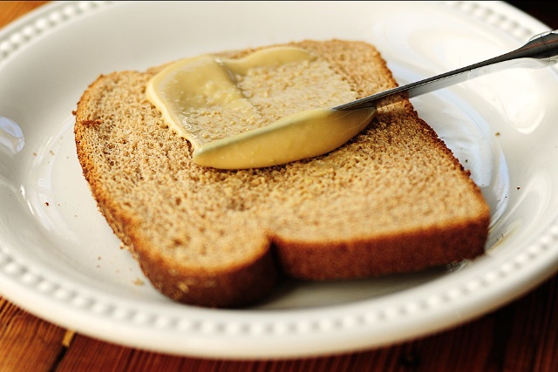

Remember to take pictures and send them to Miss Lynaugh on Class Dojo!

