Oasis Creative Week: Drama Thursday 25th June

Charades:
Can you play a game of Charades acting out your favourite books and films?

Story Puppets:

Could you make puppets of characters from your favourite story and use them to retell the story.
You could even video yourself and the puppets retelling the story.

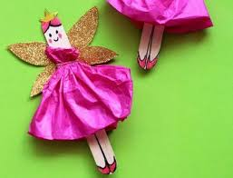
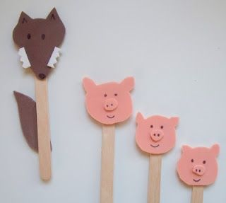
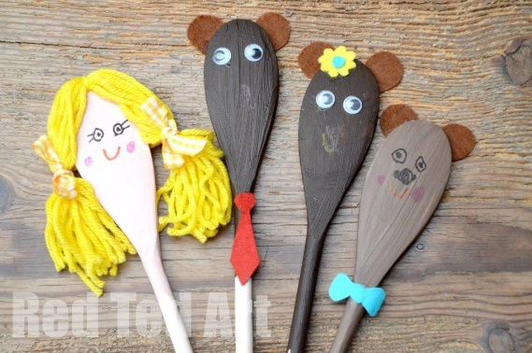
Please send a photograph or video of your dramatic activities to Miss Lynaugh on Class Dojo!

