Oasis Creative Week: Music Monday 22nd June

Gather different sized pots and pans from around your house and set them up with utensils to play them with.

You could:
- Ask an adult to play a rhythm and see if you can play the rhythm back.

- Try creating your own rhythms.

- Sing a nursery rhyme or song you love and try playing along to the tune whilst singing.
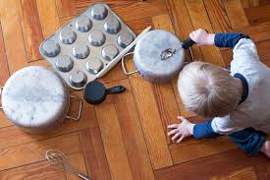

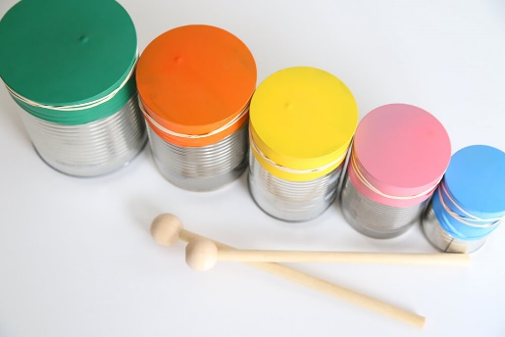
You could also try making your own musical instruments:
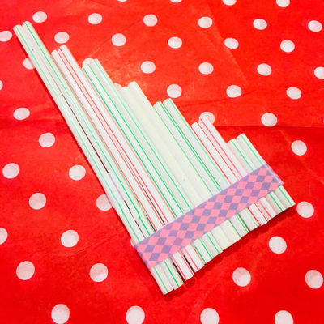
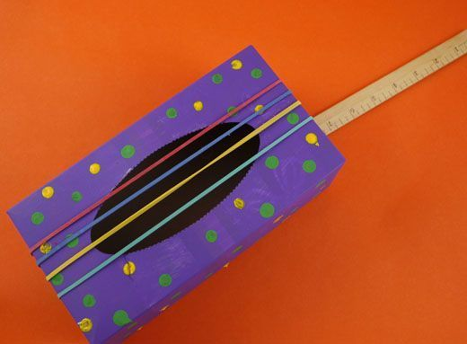
Please send a photograph or video of your musical adventures to Miss Lynaugh on Class Dojo!

