Week 1: Personal, Social, Emotional Development (PSED)

Rocking a teddy to sleep: meditation.

Meditation can be a great tool for helping your child to regulate their emotions and calm down. You could also join them and see if this helps you too.

Laying on the floor on your back, place a teddy on your tummy. Place your arms by your side and legs flat, and close your eyes.

We’re going to rock the teddies to sleep using our breathing. Slowly take a deep breath in, and then slowly breath out relaxing your body. And again…
Now breathing normally, can you feel the teddy sitting on your tummy? Rock your teddy to sleep by moving them up and down as you breath. Continue to do this until your teddy is asleep.

When teddy is asleep, slowly open your eyes, wiggle your fingers and toes and wake up teddy. How do you feel?

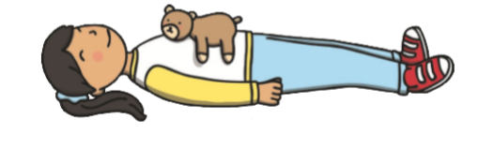

Please send Miss Lynaugh a picture of you rocking your teddy to sleep on Class Dojo!

