Week 1: Expressive Arts and Design

Creating a ladybird:

Can you use empty packaging to create a ladybird?
You could use an egg carton, cereal box, or the bottom of a plastic bottle.
You could paint or draw the ladybird if you prefer.
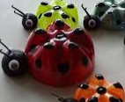
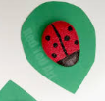
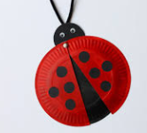
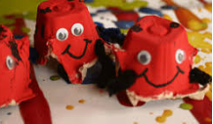

Music:
Can you sing ‘Old McDonald had a farm E-I-E-I-O’?

Please send a photograph or video of your work to Miss Lynaugh on Class Dojo!

