Week 1: Communication and Language

Talking about objects in the home.

Can you find something in your home for each colour?
You can talk about what the objects is used for, what it feels like, its weight and size.
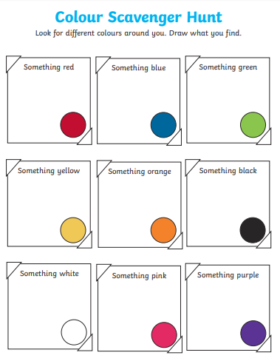

Please send Miss Lynaugh a picture of the items you found on Class Dojo!

