Week 1: Physical Development

Drawing using big movements

Can you draw 5 circles on the floor, or write your name?
You can use chalk or water and a paintbrush to make marks on the floor outside. You can use the pavement too, the rain will wash it away!
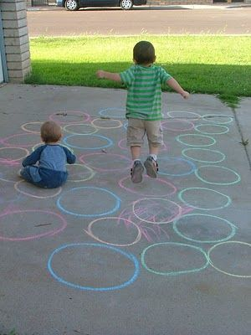

Can you use scissors?
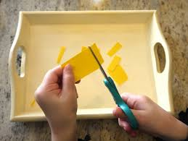
.
Can your child snip bits off a strip of paper?
Please use child scissors or small scissors.
Remember to show the sky your thumbnail!

Remember to take pictures and send them to Miss Lynaugh on Class Dojo!

