Maths
Week 1: Wednesday 1st June 2020
2D shapes.
Can you make a 2D shape?

Using twigs, sticks, pencils, or even the sticks from kerplunk, can you create these 2D shapes?

Challenge: Can you make a tower by building lots of squares on top of one another!
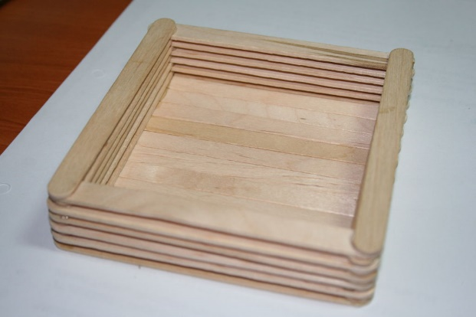

Please send Miss Lynaugh a picture of your work on Class Dojo!

