Maths
Week 4: Monday 15th May 2020
Recap: Sharing objects equally between 2 people – early division skills.
- Collect an even amount of objects between 4 and 10.

- Adults to show an even number and the child is to count the right amount of objects.

- Ask your child to share the objects evenly between the two of you, using the words ‘one for me, one for you, one for me…’ until all of the objects are shared out.

- Count how many you each have and check they’re the same. Then say ‘we both have the same amount, it is equal’

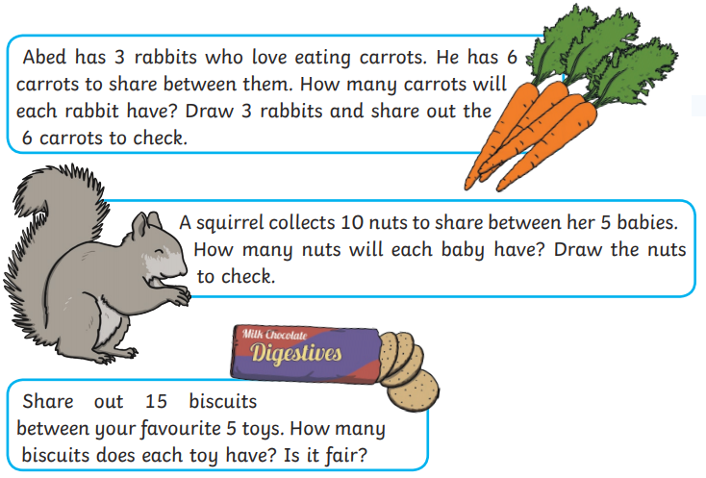
Challenge: Pick one of the challenges below to try!

Please send Miss Lynaugh a picture of your work on Class Dojo!

