Literacy

Week 4: Monday 18th May 2020

This week we will be focusing on rhyming words. Remember rhyming words are words that sound the same e.g. cat and mat or dog and frog.

Look at the pictures below, can you hear the rhyme in the words?
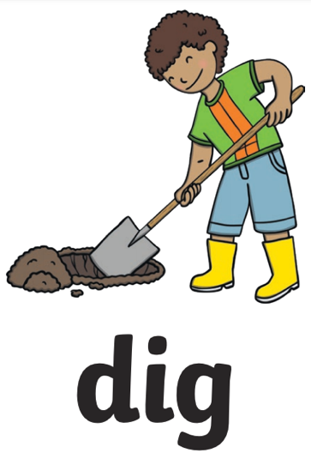
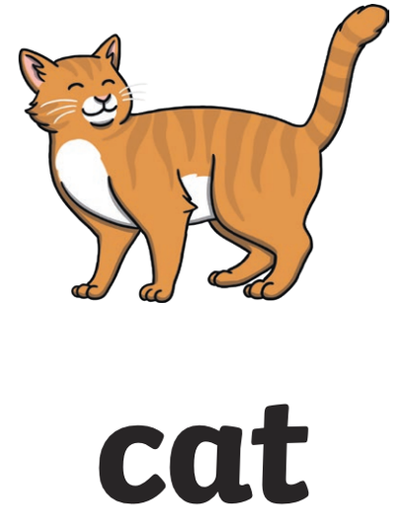
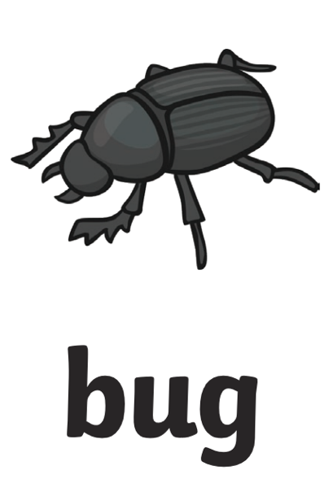
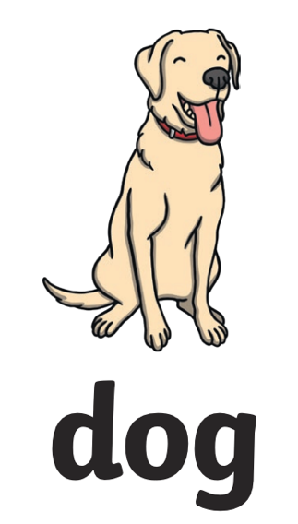

log  jog | tug  pug | bat  hat | tig  wig

Please send a photograph to Miss Lynaugh on Class Dojo!

