Week 4: Expressive Arts and Design

Creating a paper airplane:

Ask a grown up to show you how to make a paper airplane or use a YouTube to help.

Colour it in and then see whose can fly the furthest.

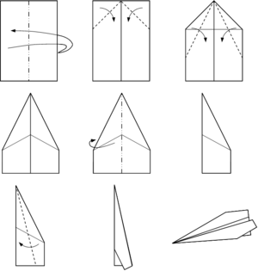

Music:
Can you tap a rhythm?
Grown-ups, tap a short rhythm and ask your child to copy. (This is called ‘call and response’) You can tap on a table with your hands, clap, or use pans and spoons!

Please send a photograph to Miss Lynaugh on Class Dojo!

