Maths
Week 3: Wednesday 17th June 2020
Capacity
Can you collect a few different containers, such as a cup, jug, bottle and a mug.
Use water, pasta, sweets or even small toys to show the different measurements.

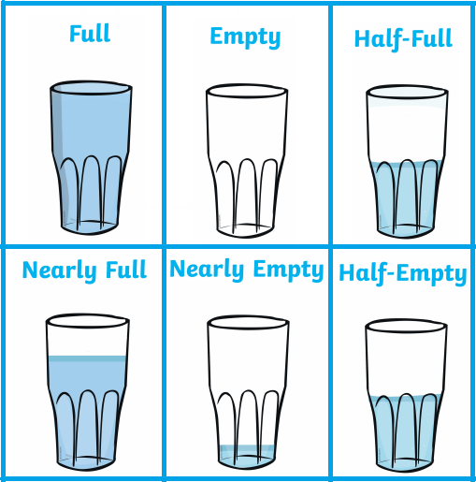

Please send Miss Lynaugh a picture of your work on Class Dojo!

