Week 3: Expressive Arts and Design

Father’s Day:

On Sunday 21st June, it will be Father’s Day.
Can you think of an important male you could make a card for?
This could be your Daddy, Grandad, Uncle or someone else who is very important to you.

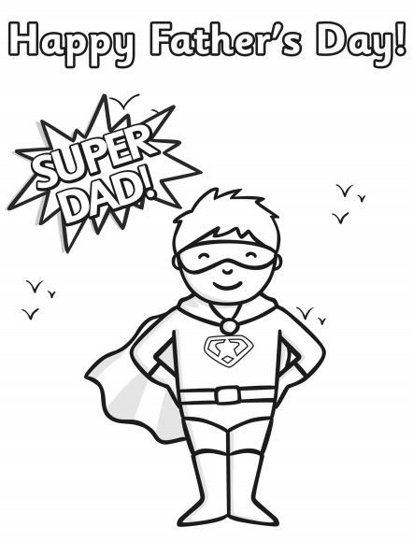

Please send a photograph of your farm to Miss Lynaugh on Class Dojo!

