Literacy
Week 3: Thursday 18th June 2020
What the ladybird heard
You can listen to the story again here:
https://www.youtube.com/watch?v=Lckjqm91LCk
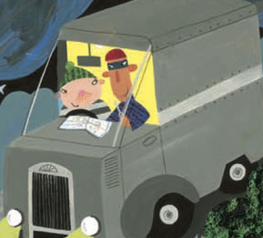
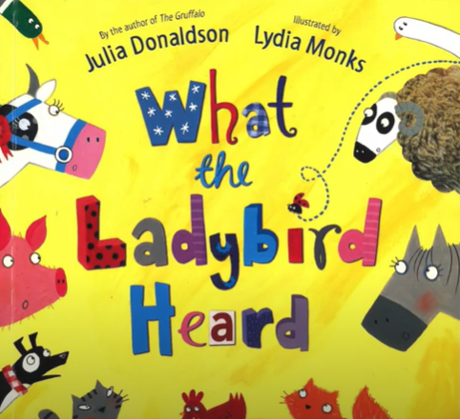

Lanky Len is the name of one of the robbers.
Can you find two objects in your house that begin with l?

Ideas:
light switch
leaf
lamp
laptop
lego

Please send a picture to Miss Lynaugh on Class Dojo!

