Literacy
Week 3: Tuesday 12th May 2020
In the story we are learning about, the caterpillar has a different meal every day of the week.
You can watch the story again here
https://www.youtube.com/watch?v=75NQK-Sm1YY
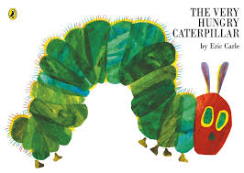

Can you put the days of the week in order, using the story? Listen to the first sound and look for that letter at the beginning. Remember that ‘th’ are special friends!
saturday | wednesday
tuesday | friday
sunday | monday
thursday

If you can remember the songs we sing, you can teach them to your grown-ups!

Please send a photograph to Miss Lynaugh on Class Dojo!

