Hand – Eye Co-ordination
Can you take your pencil through the maze without touching the lines?
Look ahead to work out your route. A sharp pencil will help.
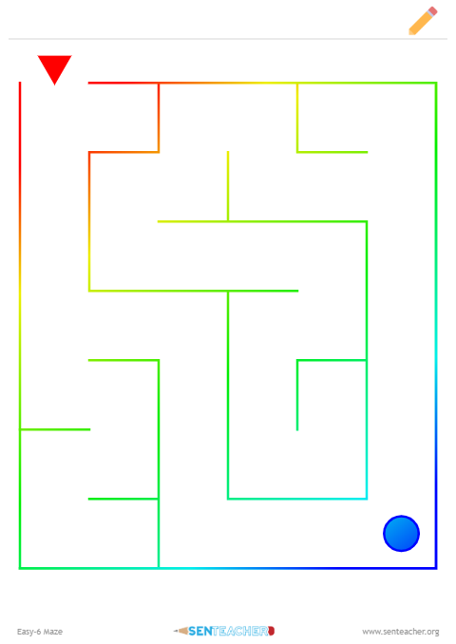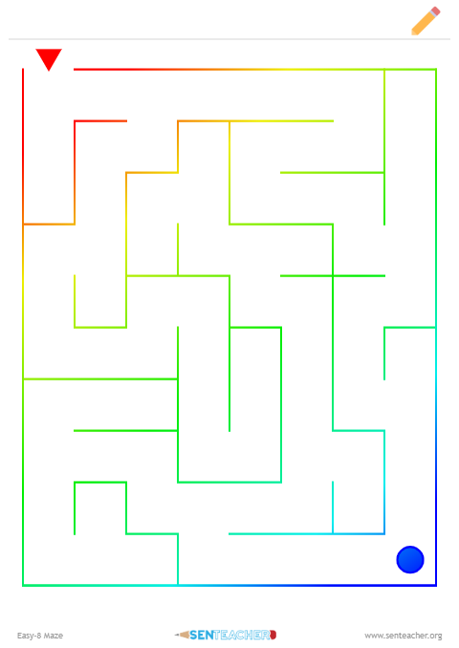

Can you take your pencil through the maze without touching the lines?
Remember to look ahead to plan your route.
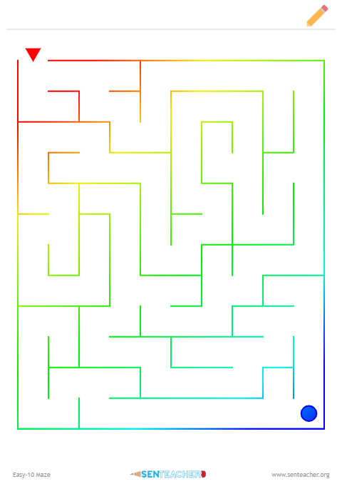
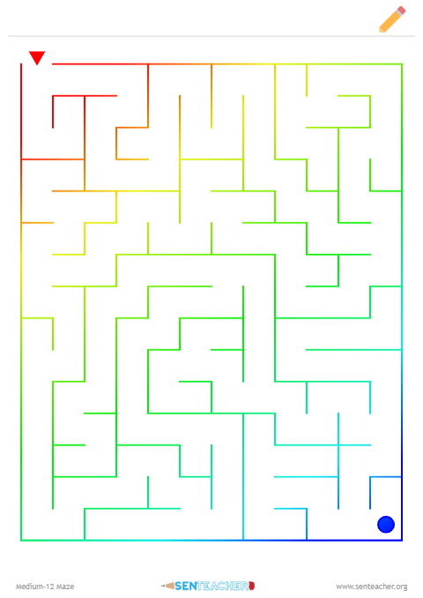

Can you take your pencil through the maze without touching the lines? Getting harder!
Remember to look ahead to plan your route.
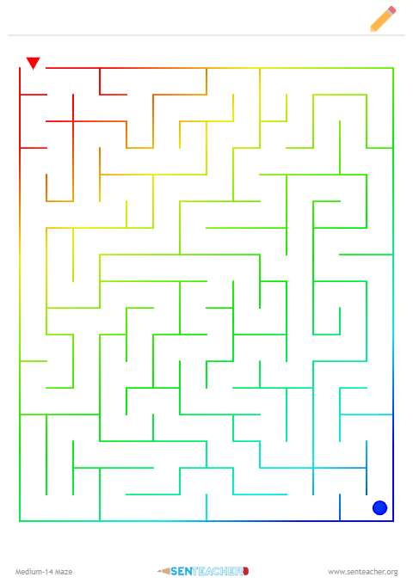
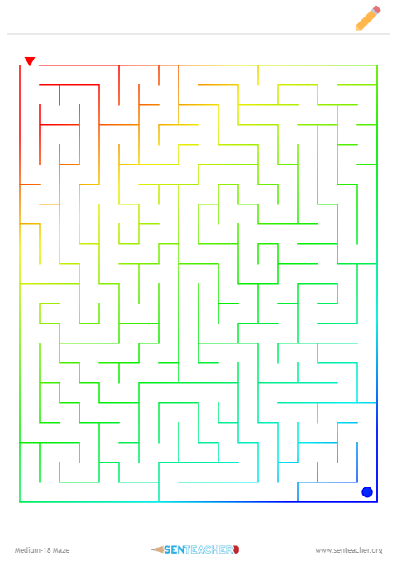

Can you take your pencil through the maze without touching the lines? Much Harder!
Remember to look ahead to plan your route.
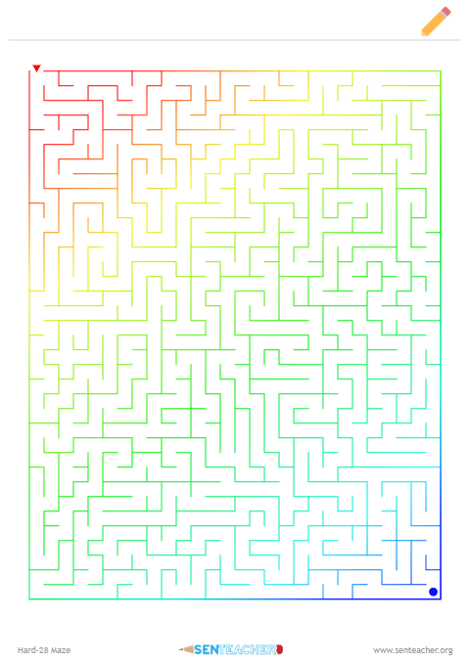

Can you take your pencil through the maze without touching the lines? Much Harder!
Remember to look ahead to plan your route.
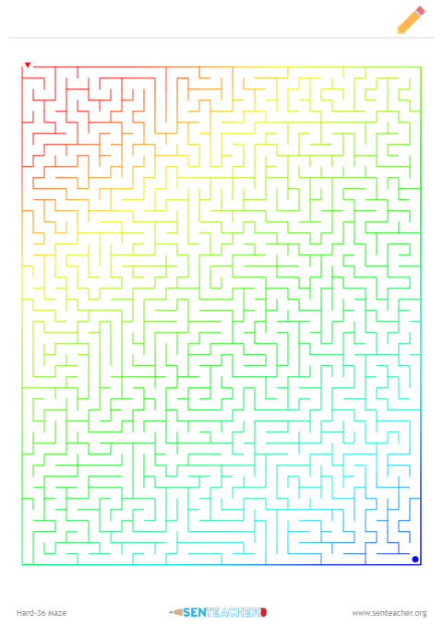

Can you take your pencil through the maze without touching the lines? How hard is this?
Remember to look ahead to plan your route.
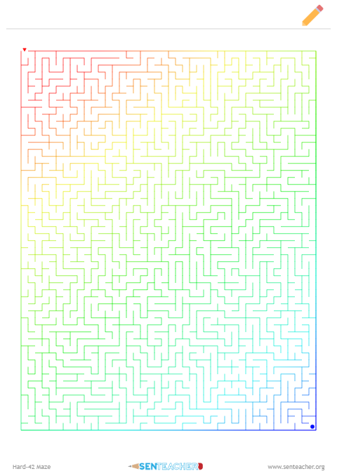

Can you take your pencil through the maze without touching the lines? Much Harder!
Remember to look ahead to plan your route.
