Wellness Activity – Week 2 – ‘Coping Toolbox’
A ‘Coping Toolbox’ is a great way to help our minds and bodies switch off from any worries we might have.
To create a ‘Coping Toolbox’, fill your box or container with anything that relaxes you or reminds you of good times that will help us to feel better.
For example: photographs, drawings, a gift from someone, favourite chocolate or sweets, bubble bath, a cuddly toy or favourite DVD.
You can decorate your container if you are allowed and want to.
If you don’t have a spare, empty container, you could find a special place to put the items or draw/write a list of your items instead.

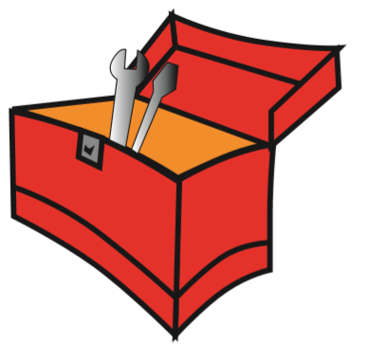
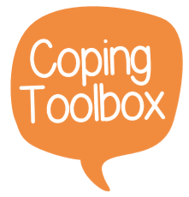

Take a picture of your toolbox for your teacher on Class Dojo – you do not need to share your chosen items if you do not wish to.

Optional:
- Discuss why you have chosen your items with an adult.
- Ask an adult to create their own ‘Coping Toolbox’ and see what your adult has chosen and why.

