Science – Week 6 – Gestation Periods

A gestation period is the scientific word for when an animal or human is pregnant – the time from conception until birth of the baby or young animal.
A new life begins as a foetus grows inside the female’s womb. Pregnancy for humans normally lasts around 9 months.
The foetus gets it’s nutrients from its mother.
It starts when a sperm cell (from a male) and an egg cell (from a female) combine.
Sometimes, two babies grow at the same time – they are called twins.
This video shows the stages of a baby growing from fertilisation to birth:
https://www.bbc.co.uk/bitesize/clips/zpmqxnb
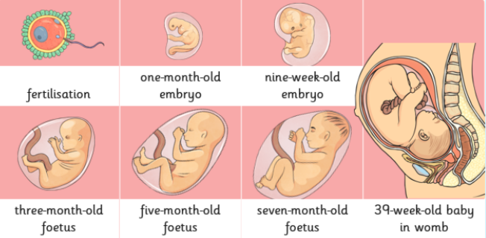

Task 1: Find out how long each of these animals are pregnant for, how many young that animal would normally give birth to, what their young are called, and how long that animal would typically live for.
Use the grid below or create your own.
Animal Name | Gestation Period | Average Number of Young Per Pregnancy | Name of Young | Average Lifespan of the Animal
Chimpanzee
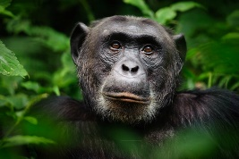
Dog
African Elephant
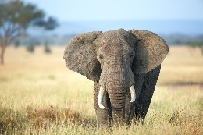
Domestic Cat
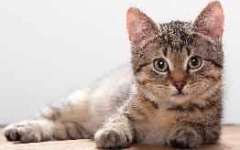
Cow
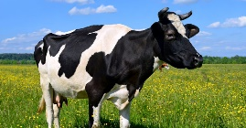
House Mouse
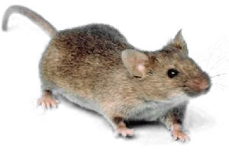
Human

Take a picture of your findings for your teacher on Class Dojo!
Task 2: Interpret your findings.
You will need your completed grid from task 1. Plot your findings in a bar chart, using the gestation periods of your animals. Give your bar chart a suitable title.
Gestation Period
If you don’t have squared paper, try your best with a pencil and ruler on plain paper.
You may colour in your bars when finished.
Animal Name

Take a picture of your bar chart for your teacher on Class Dojo!

