Maths – Year 6 – Week 6 – Finding Unknown Angles in Triangles

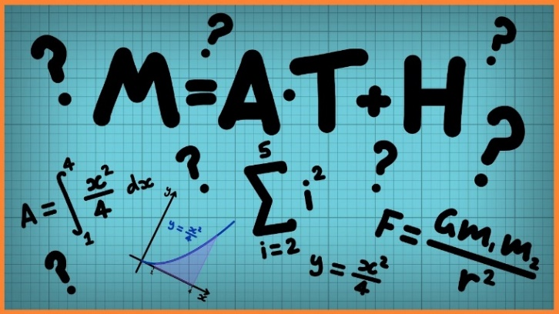
Last week, we looked at the different triangles – scalene, isosceles, equilateral and right-angled triangles.
This week, we are going to look at how to find the unknown angles within triangles. First, pictorially and then algebraically.
Can you remember what the angles within a triangle add up to?

Click on the links below to access the learning for each day.
You can work on paper if you wish to, or take a picture of your screen of work for your teacher on Class Dojo.
The activities below have been designed so that you can complete 1 activity a day. You do not have to stick to the schedule below, and you can merge the activities together if you wish to do so.
Day 1 – Introductory Quiz
https://www.thenational.academy/year-6/maths/find-unknown-angles-in-triangles-year-6-wk3-4#slide-2
Day 2 – Video
https://www.thenational.academy/year-6/maths/find-unknown-angles-in-triangles-year-6-wk3-4#slide-3
Day 3 – Main Teaching
https://www.thenational.academy/year-6/maths/find-unknown-angles-in-triangles-year-6-wk3-4#slide-4
Day 4 – Quiz
https://www.thenational.academy/year-6/maths/find-unknown-angles-in-triangles-year-6-wk3-4#slide-5

Day 5 – Finding Percentages of Amounts
Follow the link for videos & methods: https://www.bbc.co.uk/bitesize/articles/zvxnv82
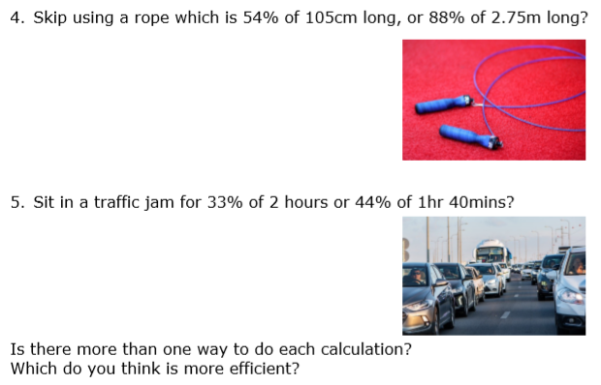
Then complete the questions:

