Literacy – Week 6 – 8.6.20

Monday 8th June – Relative Clauses
A relative clause is an extra part of a sentence that describes a noun (an object or thing), but this part of the sentence does not make sense on its own.
E.g. Do you know the scientist, whose car was stolen?
Main clause Relative clause
Relative clauses are often easy to spot because they begin with a relative pronoun. The 5 we focus on are: ‘Whose, whom, who, which, that.’

Task 1: Insert a relative pronoun (above ↑) into these two simple sentences to make one longer complex sentence – which also includes a relative clause.
E.g. ‘I like to eat pizza. It is my favourite food.’ becomes ‘I like to eat pizza, which is my favourite food.’
- My alarm broke this morning. This meant I was late for school.
- My best friends are Mel and Victoria. They walk with me to school.
- I started school in reception class. I still had blonde hair.
- I have a friend called Geri. Her house is next door to mine.
- I eat in the hall. It’s always very noisy.
- My headteacher is Mrs. Norriss. She has a friendly smile.

Task 2: Finish off these sentences so they include a relative clause – the relative pronoun has been given for you.
E.g. ‘I can’t swim, which means that I don’t like going in water.’
- Spain is a very hot country, that…
- JK Rowling is a famous author, who…
- The girl in the dress is Cinderalla, whose…
- A cat has sharp claws, which…
- Usain Bolt is a sprinter, whom…
- A bike has brakes, that…

Task 3: Relative clauses can also go in the middle (or embedded) of a sentence to give extra information about the noun they are describing. Commas go around the relative clause to show it is extra information (or parenthesis).
E.g. ‘Luke likes playing football.’
becomes, ‘ Luke, who is very sporty, likes to play football.’
- Charles Dickens, who ________________________________, was a famous author.
- The mountain, which ______________________________, was surrounded by fields and meadows.
- Cristiano Ronaldo, who ______________________________, is a famous footballer.
- Superman, whose ___________________________________, has many unique abilities.
Now choose your own relative pronoun (who, whom, whose, that, which):
- Walt Disney, _____________________________________, became a world famous artist.
- The shark’s teeth, ______________________________________, are used for biting their prey.
- The moon, _______________________________________, orbits the planet Earth.
- Queen Elizabeth II, __________________________________, is the reigning monarch of the UK.

Take a picture of your relative clause work for your teacher on Class Dojo!
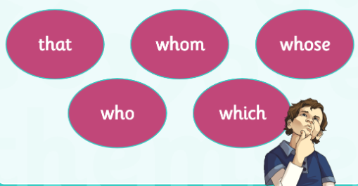

Tuesday 9th June – Reading & Questions
The Quest for Medusa’s Head
Perseus had been sent on a journey to capture the gorgon, Medusa’s head. This trophy was to be exchanged for his mother’s freedom from having to marry the evil king. Anyone looking at the face of the gorgon would be turned to stone so the challenge was dangerous and difficult. However, Perseus had help. The Maidens of the West had given him a sword, a shield, a magic pouch and cap of invisibility to protect him. Once Perseus had completed his mission and with Medusa’s head safely in his magic pouch, he headed for home to save his mother.
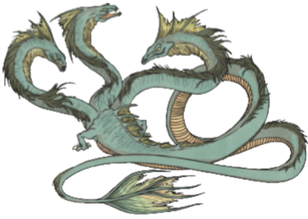
The Great Sea Beast
As Perseus made his way over the vast oceans, he came across a strange sight. He saw a beautiful girl chained to a rock by the seashore and far away a huge sea beast was swimming towards her to devour her. Quick as a blink, he flew down and spoke to her.
Perseus removed his cap and stood by her on the rock. When the girl saw him with his long hair and wonderful eyes, she thought he was the handsomest young man in the world.
“Oh, save me! Save me!” she cried as she reached out her arms towards him.
Perseus could see the sea monster coming closer so he took the Gorgon’s head out of his magic pouch, held it up high and the inevitable happened – the monster turned to stone.
Then, Perseus slipped the Gorgon’s head back into the pouch and hastened to speak with the young girl. She told him that her name was Andromeda and that she was the daughter of the king and queen of that land. Andromeda told Perseus that she was being sacrificed to the sea monster as a punishment for her mother’s vanity. As the pair talked, the king, queen and many people of the land came to see what was happening. As a reward for saving his daughter, the king agreed to let his daughter marry Perseus. Forgetting his quest, Perseus stayed happily with Andromeda and her family for many months.
The Timely Rescue
However, Perseus had not totally forgotten his mother. So, one fine summer day, he and Andromeda sailed in a beautiful ship to his own home. The ship came to land at the very spot where the wooden chest had been cast so many years before and Perseus and his bride walked through the fields towards the town.
Now, the wicked king of that land had never ceased trying to persuade Danae (Perseus’ mother) to become his wife, but she would not listen to him. The more he pleaded and threatened, the more she disliked him. At last, when he found that she could not be made to marry him, he declared that he would kill her.
So, as Perseus and Andromeda came into the town, they were greeted with the scene of his mother fleeing to the safety of the altar of Zeus with the king following, intent on killing her. When Perseus saw the king rushing like a madman after his mother, he again took the head of Medusa from his magic pouch.
“I promised to bring you a present, and here it is!” he cried.
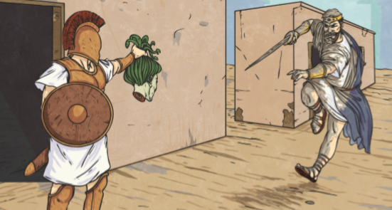
The kind saw it and was instantly turned to stone, just as he stood, with his sword uplifted and a terrible look of anger on his face. With his mother now safe, Perseus decided that they should all return home to Argos. So, the three of them set sail the following day.

Questions:
- What is the purpose of the introduction before the next part of the story begins?
______________________________________________________________
- In ‘The Great Sea Beast’, locate and copy a phrase which describes how quickly Perseus moved to save Andromeda.
______________________________________________________________
- What does the phrase “the inevitable happened” mean?
______________________________________________________________
- Why do you think Perseus forgot his quest after he saved Andromeda?
______________________________________________________________
- Why do you think Perseus and his bride continued on the quest sometime later?
______________________________________________________________
______________________________________________________________
- Write a synonym for each word so it would make sense in the story – use the text to help you.
Word in the story | Synonym
Intent
Uplifted
Foretold
Vessel
Distraught
Hastened
Pouch
Madman

- Why do you think the ‘altar of Zeus’ was a safe place for Perseus’ mother? Use your knowledge of Zeus to help you.
______________________________________________________________
______________________________________________________________
______________________________________________________________
Challenge: Write your own version of what happened to Perseus next in the adventure.
Take a picture of your work for your teacher on Class Dojo!
Wednesday 10th June – Greek Hero/Heroine
This week and next week we are going to plan and write our own Greek myth. In your myth you are going to have a hero/heroine, who has a magical weapon or object to battle a mythical monster – you will create your own!
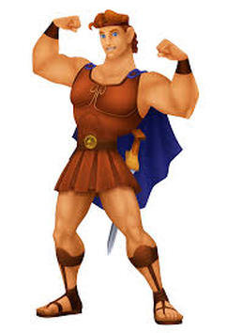
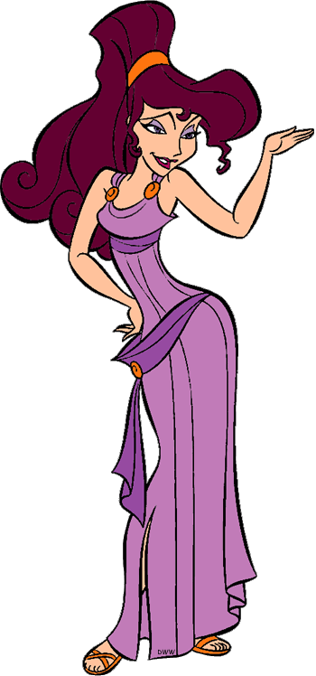
Today, we will focus on our hero/heroine – they can be male or female, and look however you wish them to look.
Think of a name for your hero/heroine and where they come from – use the internet to help you with Greek locations and name inspiration.

Task: Draw your hero/heroine and add colour. Label them to show their basic details, or write a few bullet points explaining who they are, where they come from etc.
Take a picture of your Greek Hero/Heroine for Class Dojo!

Thursday 11th June – Greek Hero/Heroine Character Description
Yesterday, you drew and labelled your Greek hero/heroine. Today, describe your Greek hero/heroine! Write a character description of your Greek hero/heroine. Make sure your writing stays in the same tense (past or present) and in the third person (they, he, she).
Choose a name for your Greek hero/heroine and make sure it has capital letters – it is a proper noun!

Try to include as many of the AfL grid points as you can:

Take a picture of your character description for your teacher on Class Dojo!
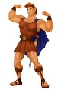
Assessment for Learning
W.I.L.F | What I think | What my adult thinks
2 Adjective Sentences
Fronted Adverbials (Time, Place, Manner)
Similes / Metaphors
Personification
Parenthesis ( ) , , - -
Challenge:
Relative Clauses

_________________________________________________________________
_________________________________________________________________
_________________________________________________________________
_________________________________________________________________
_________________________________________________________________
_________________________________________________________________
_________________________________________________________________
_________________________________________________________________
_________________________________________________________________
_________________________________________________________________
_________________________________________________________________
_________________________________________________________________
_________________________________________________________________
_________________________________________________________________
_________________________________________________________________
_________________________________________________________________
_________________________________________________________________
_________________________________________________________________
_________________________________________________________________
_________________________________________________________________
_________________________________________________________________
_________________________________________________________________
_________________________________________________________________
_________________________________________________________________
_________________________________________________________________
_________________________________________________________________
_________________________________________________________________
_________________________________________________________________
_________________________________________________________________
_________________________________________________________________

Friday 12th June – Determiners
Determiners introduce a noun.
For example: ‘The Queen…’ or ‘My Queen…’ or ‘A Queen’.
For example: ‘Our dog…’ or ‘Their dog…’ or ‘Two dogs…’.
Specific Determiners refer to a specific noun, when the reader knows exactly what you are talking about:
- The, this, those, which, these, that, her, his, those, our, their, my, your.
- E.g. ‘Your pet budgie is smiling at me.’

General Determiners refer to general nouns that the reader does not know – they can also tell the reader how many nouns you are talking about.
- A, an, any, another, other, what, some, few, five, more, many, any, less.
- E.g. ‘Five ice-creams cost two pounds.’
Don’t get caught out by adjectives! Adjectives come after the determiner, but usually before the noun, the adjective in this sentence is beautiful.
For example: ‘Her beautiful dog ran quickly.’

Task 1: Can you identify the determiner in these sentences? Hint: There is only one to find.
- The hoop rolled and wobbled.
- The long river swished and swooshed loudly.
- Whose socks are these?
- Five scary seagulls soared majestically.
- Any computers must be turned off.
- Those trees are very tall.

Task 2: Can you identify the determiners in these sentences? Hint: There are two determiners to find!
- The football rolled down the hill.
- The lost village is just beyond those trees.
- Six dogs ran all over the vast field.
- Her dark hair blew in the wild wind.
- Two ice-cream vans arrived in the street.
- Our Queen lives in a huge house.

Task 3: Can you identify the determiners in these sentences? Hint: There are more than 2 in each sentence!
- I put my bedroom light on because the daylight was fading.
- Several furious members of the gang held a meeting on their motorbikes.
- Five bees were buzzing around the sunflower in our garden.
- His boots were brown, just like his eyes and his long hair.
- Quick! My tea is burning and the smoke is in our kitchen!
- That witch has ten shrieking bats and five black cats.

Take a picture of your determiner work for your teacher on Class Dojo!

Extra Activity:
