Art – Week 6 – Greek Coins
In 600 BC, the first Greek coins started being used, in return for goods, animals, items and even slaves. The Ancient Greeks enjoyed art and took pride in their possessions, so (just like with their vases), the Greeks designed and decorated their coins too. They would be decorated with warriors, kings, monsters and sporting events like chariot racing. Coins would be made out of gold and silver.
Here are some examples of Greek coins archaeologists have found:
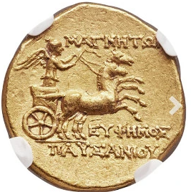
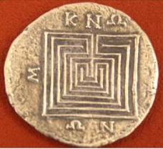
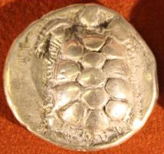
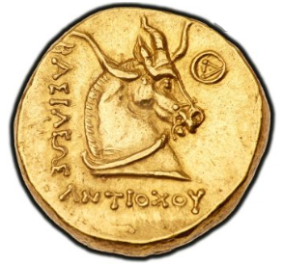
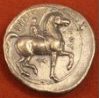
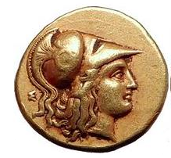
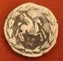
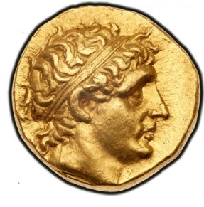
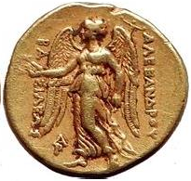

Can you design your own Greek coins? Think about the Greek myths we have covered and the heroes and monsters we have learnt about.
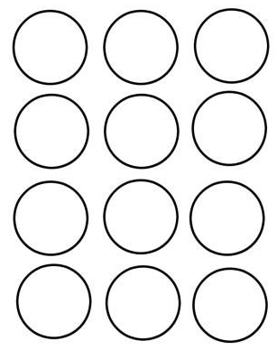
Use the templates or draw your own!

