Design a VE Day Medal
This medal celebrated the end of the First World War and was given to soldiers who had fought in active theatres of the war. It was a symbol of great pride but its design was also highly symbolic.
The colours are the combined colours of the Allied nations with red at the centre.

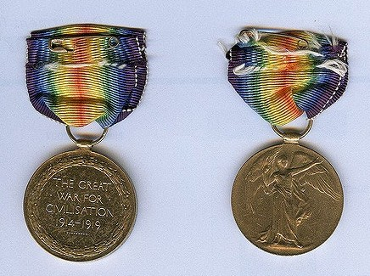Bronze medal, not too expensive after the war, but long lasting.
The years of the First World War –
1914-18
A rainbow symbolises the calm after the storm.
Winged figure is ‘Victory’.

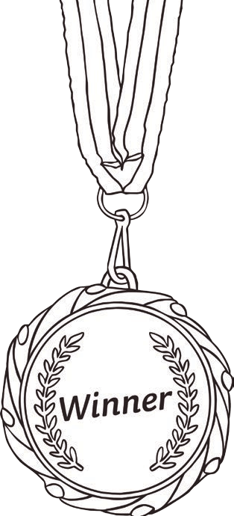

Your task is to create a medal for British soldiers who served in the Second World War that is just as symbolic and creative.
Your medal can be any shape or size but you must have considered the metal and ribbon choices.
You must include:
- The years of the war (1939-45)
- The colours of the Allies
- A symbol to signify the war and the soldier’s sacrifice and victory
- A reference to the many theatres of the fighting (Europe, Africa, Asia, Air, Sea, Land)
- Annotations to explain your choices

Upload photos of your completed design onto Class Dojo

