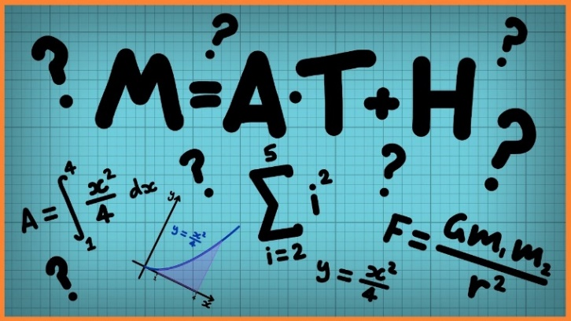
Week 2 Decimal and fraction equivalence
This week, we will be learning how to compare equivalent decimals and fractions.
Click on the links below to access the learning for each day.
You can work on paper (but you don’t have to) or click on the screen and upload a photo onto Class Dojo showing your completed work.
These activities have been designed so that you can complete 1 or more activity a day. You do not have to stick to the schedule below and you can merge the days together if you wish to.
Day 1- Quiz
https://www.thenational.academy/year-6/maths/decimal-and-fraction-equivalence-year-6-wk2-1
Day 2 -Video
https://www.thenational.academy/year-6/maths/decimal-and-fraction-equivalence-year-6-wk2-1
Day 3-Main Teaching
https://www.thenational.academy/year-6/maths/decimal-and-fraction-equivalence-year-6-wk2-1
Day 4- Quiz
https://www.thenational.academy/year-6/maths/decimal-and-fraction-equivalence-year-6-wk2-1
Day 5 – Develop your reasoning skills by completing these challenges.
https://www.bbc.co.uk/bitesize/articles/zhvx6v4

