Ancient Greece – Week 2 – Years 5 & 6 – Summer Term
Democracy was created in Athens (the modern day capital city of Greece) over 2400 years ago.
Can you remember what ‘democracy’ means?
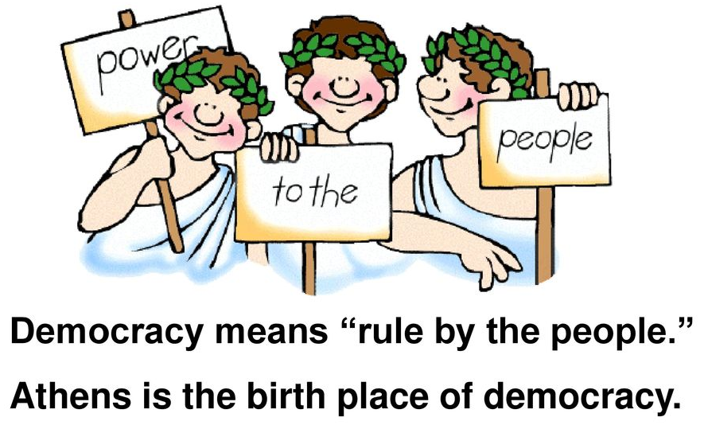
Democracy is where citizens have the right to vote on their government and who represents them. We have democracy in the UK today – anyone over the age of 18 can vote in elections to have their say on the actions of the government.
Can you remember the name of our current Prime Minister?
(Answer: Boris Johnson)

However, in Ancient Greece times not everyone could vote! Women, children and slaves were not classed as citizens so did not have a say in how the government was run. Only if you were born in Athens did you also have the right to vote. Do you think this is really democracy?
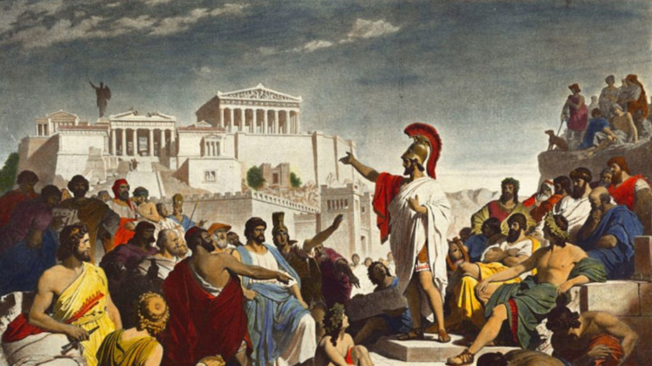
Task 1:
Sort these Ancient Greece people to show whether they could or could not vote in Ancient Greek times. (A metic is someone not classed as an Athenian citizen.)
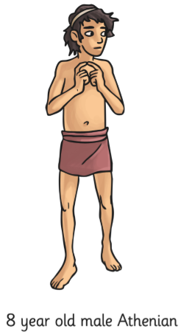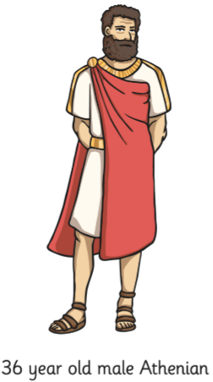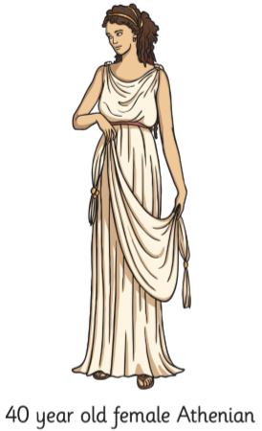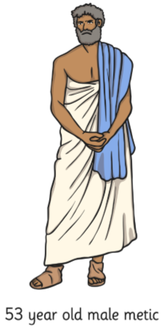
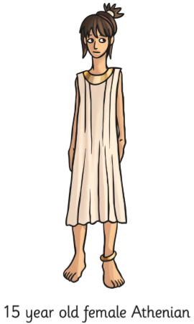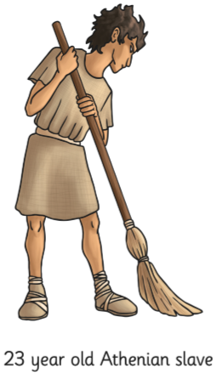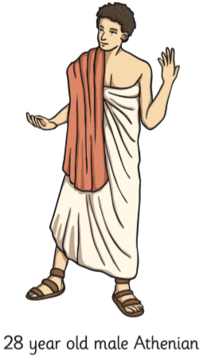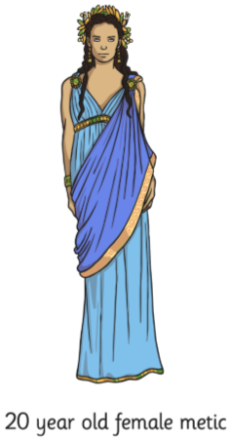
Insert the descriptions into the table below – you can create your own on paper. Photograph your finished tables for your teacher on Class Dojo.
COULD vote | COULD NOT vote

Task 2:
Democracy has changed over thousands of years since it was created in Athens.
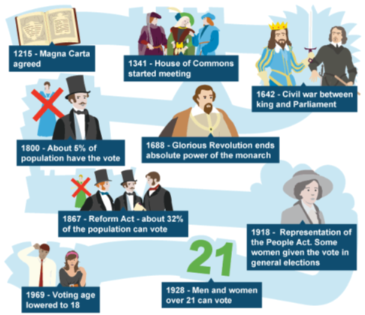
Almost 100 years ago, men and women over the age of 21 were given the right to vote, just over 50 years ago that age was lowered to 18. For many years, only certain men, of certain ages and certain families were allowed to vote.
Today, the UK is a democracy with laws made by Parliament that have been elected by the people (anyone above the age of 18).
Your task: Can you think of examples as to when democracy is used in today’s modern world? Hint: when do we use democracy in school?

Create a list and photograph it for your teacher on Class Dojo.

