Year 5 & 6 science
Summer Term 1
Living things and their Habitats.
Week 2
Prior Learning
What did you learn last week in science?

What is a mollusc?

Can you name three different mammals?

What is the difference between an amphibian and a reptile?
Activity 1- Tick the correct statements below
 | Statement | Mammal | Bird | Reptile | Amphibian | Fish
1 | It is cold-blooded.
2 | It is warm-blooded.
3 | It has scales and fins.
4 | It lays eggs.
5 | It gives birth to live young.
6 | It can live on land and under water.
7 | It has webbed feet and wet skin.
8 | It has feathers and wings.
9 | It has scales and dry skin.
10 | The mother provides babies with milk.
Activity 2
Classifying Organisms
Choose a habitat from the list below, or think of your own.

Habitats:
Amazon rainforest Great Barrier Reef Galapagos Islands
British woodland or your garden
Task 1
Find out the names of 10 to 20 animals and plants that live in this habitat.
Task 2
Classify these organisms into the correct groups.

My habitat _____________________________________

List of plants and animals: Type in the names below

mammals:  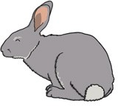 | birds:
amphibians:  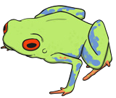 | reptiles:  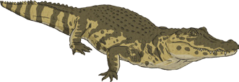
fish:  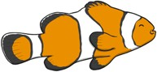 | insects:  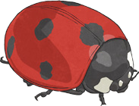
arachnids:  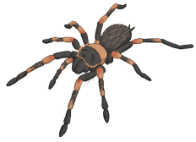 | annelids:
echinoderms:  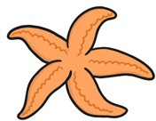 | crustaceans:  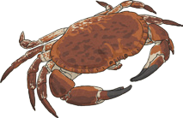
molluscs:  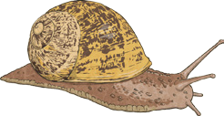 | flowering plants:  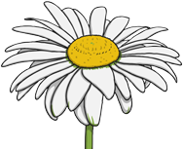
non-flowering plants:

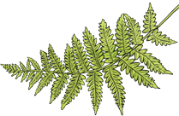
Word bank

Then upload photos of the completed activities onto Class Dojo for us to see.

Have fun!!

