For DT we would like you to create your own labyrinth.

Can you help Theseus find the Minotaur in the maze?

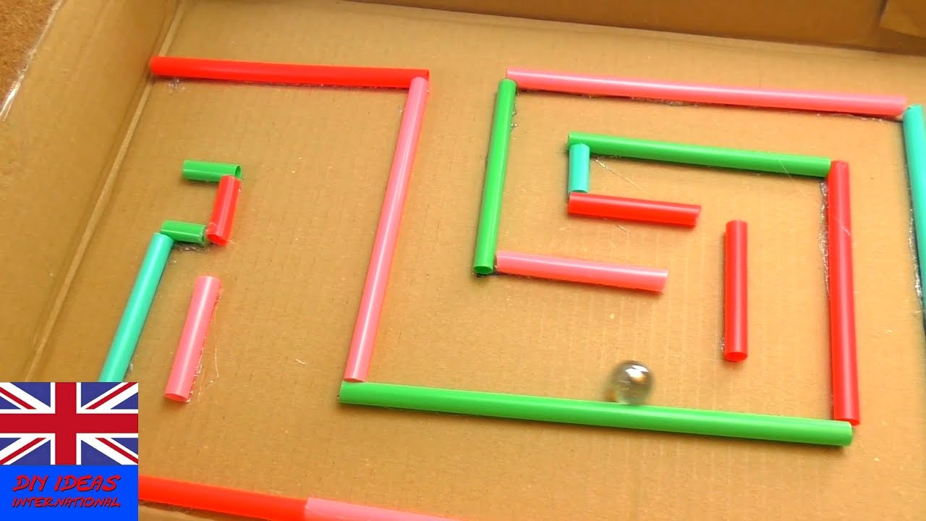

For your labyrinth you will need:
- Straws (cut to different sizes)
- Marbles or small beads or small balls
- Paper plate or lid of a shoe box or any cut out cardboard box

Make your designs as complicated or as inventive as you would like to.
Then upload a photo of your finished maze onto Class Dojo.
Let’s get creative

